Project Design Phase-II
Technology Stack (Architecture & Stack)

Date | 6 February 2026
Team ID | LTVIP2026TMIDS24222
Project Name | Flavour Fusion: AI-Driven Recipe Blogging
Maximum Marks | 4 Marks

Technical Architecture:
The Deliverable includes the architectural diagram as below and the information as per the table1 & table 2
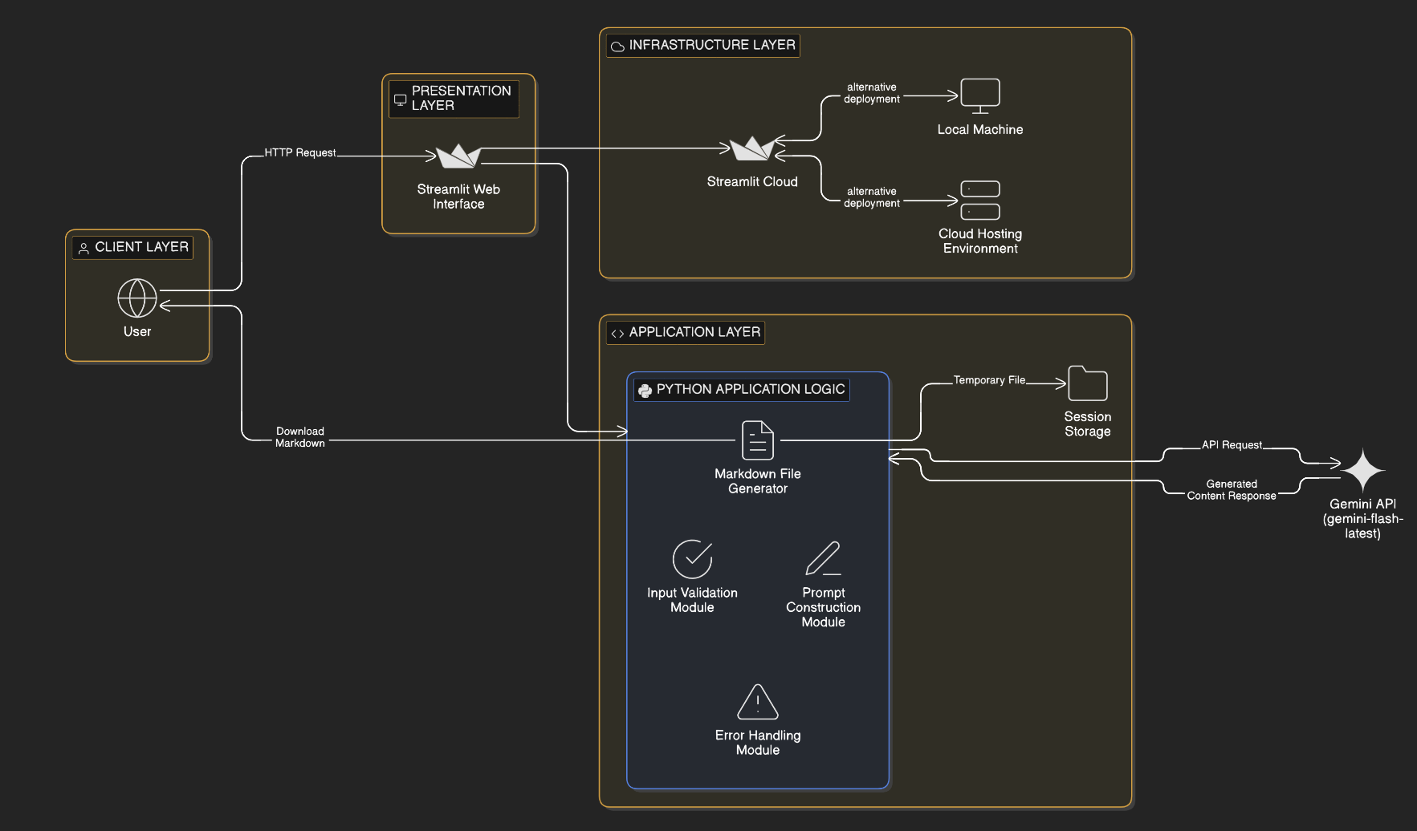
Table-1 : Components & Technologies:
S.No | Component | Description | Technology
 | User Interface | Web-based interface where users enter recipe topic and word count, view generated content, and download Markdown file. | Streamlit (Python-based Web UI)
 | Application Logic-1 | Handles user input, validation, and workflow control | Python
 | Application Logic-2 | Prompt construction logic for structured recipe generation | Python (Prompt Engineering Logic)
 | Application Logic-3 | AI content generation logic via external model integration | Google Gemini API (gemini-flash-latest)
 | Database | No persistent database used (stateless application) | Not Applicable
 | Cloud Database | Not used in current implementation | Not Applicable
 | File Storage | Temporary generation of Markdown file for download | Local Runtime (Streamlit Session State)
 | External API-1 | AI text generation for structured recipe blogs | Google Gemini API
 | External API-2 | Not used | Not Applicable
 | Machine Learning Model | Large Language Model used for generative content creation | Gemini Flash Model
 | Infrastructure (Server / Cloud) | Application can be deployed locally or on cloud hosting platforms | Local System / Streamlit Cloud / Any Python-supported Cloud Environment

Table-2: Application Characteristics:
S.No | Characteristics | Description | Technology
 | Open-Source Frameworks | Framework used to build and deploy the web interface | Streamlit (Open-source Python framework)
 | Security Implementations | API key secured via environment variables or Streamlit secrets; no sensitive user data stored | Streamlit Secrets / Environment Variables
 | Scalable Architecture | Stateless architecture; scalability depends on hosting environment and Gemini API limits | Streamlit + Cloud Hosting (Horizontal scaling possible via cloud deployment)
 | Availability | Application availability depends on hosting platform uptime | Streamlit Cloud / Cloud Hosting Provider
 | Performance | AI response time depends on Gemini API latency; lightweight UI ensures minimal frontend delay | Python + Gemini API

